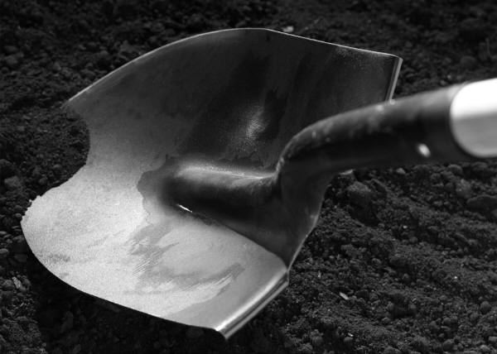 Part One: Excavation
I decided a few years after attaining my doctorate in history that I also wanted to study archaeology in a formal way. This urge was prompted by a need to get out of the archives and out-of-doors! I’ve had the privilege of working on a number of sites and the act of excavating has taught me a number of things that can be applied to our work here. I’ve listed these lessons below and how they relate to self-excavation.

- Be Patient.
  - On a site: Digging requires that you work methodically and with focus. We literally take the layers of a site down inch by inch with a trowel while looking for artifacts and other physical signs left behind in the dirt of settlement. You must be both careful and attentive.
  - On yourself: Be patient—you are a work in progress and you’ve lived a life beforehand that you are now seeking to examine. Be gentle with yourself.

- Don’t Dawdle.
  - On a site: Yes, I know—this seems to contradict what I’ve said above. However, most projects are limited by time, not open-ended. So, while you need to be prudent you cannot afford to take forever to get through your assigned patch of earth. You cannot be so tentative that you fail to get the job done.
  - On yourself: Don’t dawdle—gentle doesn’t mean lazy. You’ve set out to create a new and artful life, so don’t be too timid to get it started. Change comes with work. Make a schedule and stick to it.

- Be Open to Reinterpretation.
  - On a site: On many projects we have started from one premise or theory only to have it entirely changed by new evidence. You cannot be entrenched in your thinking.
  - On yourself: Be open to reinterpretation. Most people have set ideas about themselves as well as their past and futures that hold them back. Be willing to reexamine your life in a new light and accept possibilities you may not have thought of before.

- Be willing to accept unanswered questions.
  - On a site: Sometimes you just cannot figure how something fits or what it means because you don’t have enough information to work from.
  - On yourself: You may not figure everything out all at once. This is a gift not a limitation. What fun would it be if you already knew everything about yourself?

- Be prepared for tough conditions.
  - On a site: Your work often needs to be done in non-ideal conditions. It may be boiling hot and humid, or freezing cold and rainy—the work still needs to get done. So, you need to not let yourself be waylaid by non-optimal conditions.
  - On yourself: Be prepared for some tough conditions. Excavation may mean revisiting unpleasant times or recognizing aspects of yourself that you would rather leave buried. Do it anyhow!

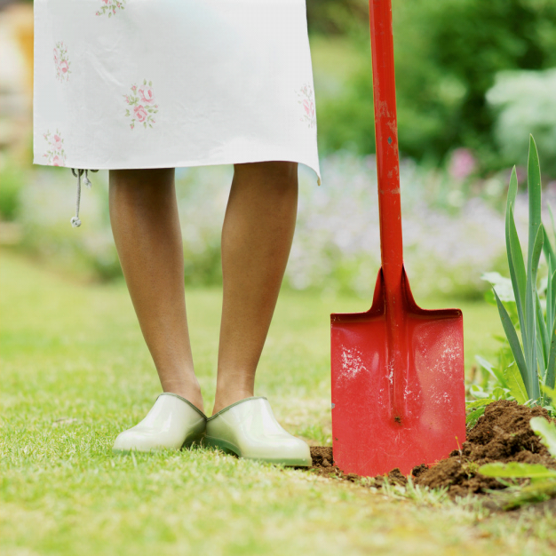
Keep Digging—Keep Discovering!

