Indian Summer
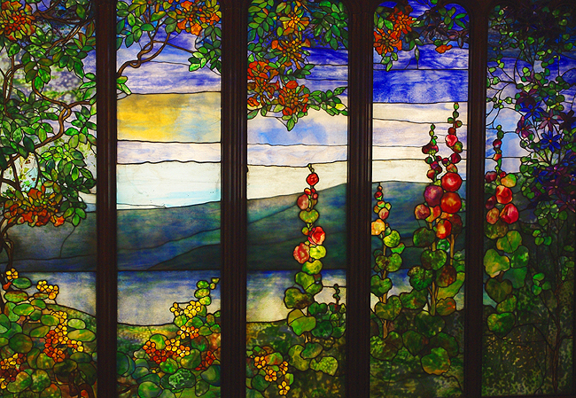
Louis Comfort Tiffany, Hudson River Scene, 1905 (on display at Corning Museum of Glass, NY)
These are the days when Birds come back-
A very few-a Bird or two-
To take a backward look. These are the days when skies resume
The old-old sophistries of June-
A blue and gold mistake. Oh fraud that cannot cheat the Bee-
Almost thy plausibility
Induces my belief. Till ranks of seeds their witness bear-
And softly thro' the altered air
Hurries a timid leaf. Oh Sacrament of summer days,
Oh Last Communion in the Haze-
Permit a child to join. Thy sacred emblems to partake-
They consecrated bread to take
And thine immortal wine! --Emily Dickinson
I wanted to start with the gorgeous image of Indian Summer—a most perfect seasonal phenomenon. This last respite before the cold and rain of November sets in always feels like such a lovely blessing. Clearly, Emily Dickinson likens this “blue and gold mistake” to something akin to a religious experience. The crisp blue skies, the cool nights and warm days, the kaleidoscope of colorful leaves, and the profusion of vegetable fruits and flowers: apples, pumpkins, gourds, mums, asters and autumn sedum (just to name a few). According to Native American legend, Indian summer was granted by the gods when a farmer, who had been ill during the planting season, found himself with nothing to reap at harvest time. The gods bestowed upon him a period of good weather which allowed him to get his seeds in late. The plants bloomed exceedingly quickly and profusely, and he headed into winter with plenty to eat. Most of us aren’t storing our food supplies for winter, but that doesn’t mean that we can’t use this metaphor of the last minute gift. Take this time to enjoy a bit more outdoor fitness, to play with your loved ones, and to bask in the light of the sun. Indian summer presents us with the opportunity to feel as though a special privilege has been given (one that should not be squandered). Don’t let the days of Indian summer pass by without appreciating them to their fullest.
I’ll share a memory from several years ago. My daughter was 5 years old and I was off from work. We spent the day exploring a nearby town where there were a couple of farms running special fall events. We ran around in a corn maze at a corn farm. We pretended to be the characters from Scooby Doo. Of course she got to be Daphne, the pretty one, and I had to be Velma (the bookish one in a frumpy outfit with enormous glasses). After that we found a Christmas tree farm that was running a Halloween scavenger hunt. You received a list of items that you needed to try to find in the trees, easier said than done, but we had a blast. We ended the day on a hayride where she treated the other wagon riders to a rousing version of “Take Me Out to the Ballgame.” The weather was perfect and it is an experience I will never forget. We still go out to that same farm to play the scavenger hunt every year. I keep hoping that she’ll never say to me that she’s too old to enjoy it.
Indian summer reminds us not to take anything for granted. It emerges suddenly and takes our breath away. It allows us to feel the lightheartedness of summer for just a bit longer, yet there is always the undercurrent of knowing colder, darker days are to come. Instead of dreading those days, we need to jump into the joy of Indian summer with gratitude and drop all expectations that it will go on forever. In that sense, it stands as a metaphor for life. If we are fortunate, life is mostly good. However, none of us can escape suffering and pain entirely. Difficult times remind us, or at least they should, that good times are to be cherished. Let Indian summer remind you that life can suddenly surprise you with all being well in the world.
Ways to appreciate Indian Summer:
- Find a fall festival!
- Buy some pumpkins and mums for decoration
- Make a scarecrow—fun family project
- Listen to some bluegrass or folk music—it just seems to fit (folkalley.org streams great music)
- Go hiking and appreciate the colors of autumn
- Pick some roadside wildflowers. They won’t last long but they’ll bring you cheer.
- Make a pot of chili (with ground turkey, chicken or all beans and veggies)
- Wear the colors of Indian summer—buy a scarf or necklace (or both) in shades of blue, gold and orange. I love turquoise jewelry this time of year.
- Treat yourself to a nail polish in one of these shades as well—make it as rich or punchy as you like.
- Play in the leaves, throw a football, do something fun and out of doors that reminds you of being a kid
As for today’s inspiration pieces, Louis Comfort Tiffany is known for the famous jewelry store he founded, but it is his glasswork that I find truly enchanting. The jewel-like colors, the gradations, the layering of both form and color, and his wonderful depictions of flora never fail to enthrall me. I chose the Hudson River Scene because of the blues, yellows, reds and greens it offers—it reminds me of Indian summer. Emily Dickinson is one of our most celebrated American poets but she was not appreciated, or even published much, during her lifetime. Her life was deeply affected by the number of family members and friends who died and she felt at many points that she simply couldn’t cope. Despite her depressing circumstances, she wrote some of the most honest, interesting, crisp and clever poetry in the last couple of centuries. My high school English teacher, who was the single most influential teacher in my life, thought Emily Dickinson the finest poet he’d ever read—and he read A LOT. So, read and look around you. Enjoy the gift of Indian summer.
Contemplation #1:
Think about your favorite fall memories. Is it going to a high school Friday night football game? Going on a hayride? Isolate the sounds, smells, tastes and sights that made it special. Write down the adjectives as you are remembering. Cherish the memory and recreate it in your mind’s eye. Perhaps share your thoughts with a friend or family member and plan how you can create a special memory this month.
Contemplation #2:
Think about a time when you received a gift you didn’t expect. It may have been the gift of a day off, or something tangible that someone gave you. Recently, I came home from work to find that my daughter had straightened up all the bathrooms and bedrooms upstairs. Had replaced the towels, scooped the cat box and sorted the laundry. This was after she’d been chided in the morning for not doing enough around the house. She gave me a wonderful gift that made me proud.
Creative Project: Preserving leaves in glycerin
This process allows the leaves to stay soft and bright!
http://www.marthastewart.com/271616/preserving-leaves
Live in love, fully and artfully
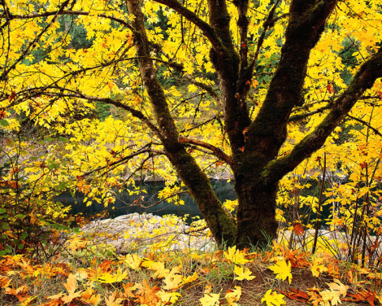 Lisabeth

